Tuesday, October 13, 2020

Here in California I’ve been really getting settled--not only getting my apartment set up and furnished, but also logistical adult things like health insurance and car insurance. Anyway, now that the majority of that is seemingly behind me, I’m focusing more on my technical projects.

I’m trying to approach this with a strong eye towards the future. I’m trying to really build capability. Capability as an aerospace engineer, and capability as a matter bender.

This means a few things. Firstly, it’s building skill with new tools. New analytical tools, as well as physical tools. Also, I need to work on using documentation like this to focus my energies while also providing technical documentation of my accomplishments.

For the Edge 540 project specifically, I’m working on the following:
- Improving my aerodynamic analysis skills with XFLR5
- Doing proper structural analysis, even mediocre for now
- Coming up with structural allowables and using them…. Even if I have to be super conservative.
- Using better computer tools for this analysis. For example, studying the loads within a wing backed out from XFLR5 and using them for my structural analysis.
- In general, actually going through more of the design process.
- Test, test, test….

So far I’ve been working on initial material testing for balsa wood. I haven’t yet started working with ply, but I recently bought a jig saw and brought my hand saws into the apartment so I expect I’ll be able to start heading in that direction soon. I’m stuck in an odd place where my material tests are providing increasing values with almost every test. The variance is tremendous (not a huge surprise), and I’m wondering if I could be doing something wrong. For example, my first flexural test of a piece of .25” x .5” balsa gave a max stress of 800 psi. A more recent test gave almost 2000. At the same time, I am wondering if that’s not the right test to be running. I am tempted to put together a beam (like an I-beam) and try to break it. I just hate how much material that would use. I have a limited stockpile of balsa, and supply is never guaranteed. Anyway, I suspect that such a test would give me better insight on the strength of these parts as they are used in actual wing construction. For example, I suspect that the tensile strength of balsa is probably sufficiently high compared to both the shear and flexural strengths that such a beam would fail near the glue joints connecting the shear web and caps. I say “near” the glue joints because in my experience typically glue joints in balsa fail in the wood grains just behind the glue joint. I think it could be very advantageous to put together an understanding of what that looks like in an actual aircraft build.

Today I did a double-shear glue joint test. The joint was strong enough that it was off the scale for my gram scale. I had to use my analog bathroom scale, which is highly imprecise. I also attempted a test of a single shear glue joint in the direction perpendicular to the grain of the wood. I had trouble breaking that as well. I also attempted to test a glue joint with the long grains sheared against one another side-by-side. I may have made it too large of a bond area, as I’m really having trouble breaking that in shear. Measurement is also a problem. I would like to transition to using my load cell for higher-load tests, but I don’t have a good system for packaging the load cell and applying the load. My multimeter is hardly sufficient for measuring that data. The arduino analog-to-digital converters also are borderline because they only have a resolution of 4.9 mV. With my load cell, that corresponds to a resolution of 6.033 kg, or 13.3 lbs. That’s horrible. It’s possible that it’s a fault with my load cell, and that the slope should be different. Admittedly, if my source voltage were higher, maybe it would give me better resolution.

October 16, 2020

I didn’t make any progress on design today, but I did increase capability by way of buying tools. Today I bought a cheap band saw and belt sander. I’m hoping to use these for manufacturing of parts for this project. Sure, it would be nice to get parts laser cut, but it’s a pain having to deal with other people. I’d rather do it myself as much as possible. Some additional work is needed before I can use these tools. I need to put them on a better work surface, as they’re currently resting on a flimsy 4’ folding table from Wal-mart. Because I need to maintain portability (because my living situation is highly likely to change in the coming years), I actually would like to stick with the folding table. Unless I find a more sturdy but collapsible alternative. To mitigate some of the downsides of this, I have a few ideas:

Bolt the machines to a piece of wood (probably ply), which I can then clamp to the table. I can place pieces of wood underneath the table for a better bottom clamping surface. On top of this assembly, I want to build a simple enclosure to help contain saw dust. I plan to line it with sound-absorbing panels made up of enclosed towels. I plan to have routings to hook up a shop vac to collect dust. I need to not make a mess in that already crappy garage. If I do, I’ll never get my deposit back. Here’s the primary challenges to all this:
- Making this structure come apart easily for transportation.
- Trying to keep things lightweight--again, to make transportation easier
- Not accidentally ending up with a structure that resonates with the machines’ vibration and therefore amplifies the sound. This is a BIG risk.
- Ending up with a structure that does its job (contains dust and noise), but doesn’t provide so much physical interference that I can’t use the machines effectively.

Requirements:
- Must Have sound-absorbing panels that clear the moving parts of the machines by a great distance. There should be a near-zero probability of catching material in the machines.
- Must facilitate collection of dust with a shop vac or dust collector
- To the extent possible, should not shake and/or vibrate with the machines
- To the extent possible, should not interfere with the usability of the machines. There should be accommodations for cutting long pieces of material with the band saw.
- Should come apart for simple transportation
- Should be made of materials of sufficient strength and minimum weight.
- Should have routing for electrical power, dedicated power strip optional

It seems I need to do some more research on these machines. One of the big uncertainties is addressing how the dust is collected. It’s unclear to me, for example, whether an external source of propulsion is necessary, or if the band saw (in particular) has an integrated fan that spins with the blade to collect dust and send it out the hole.

I did not purchase a drill press today. In some ways, a drill press may be simpler. It may still require a somewhat complex mounting scheme, but there will likely be less need for thorough dust collection and possibly sound insulation. I’m uncertain how I want to do the spacing of these machines. Do I size the wood platform to the table so I have room to optionally put a drill press in the middle? This would also save room between the two machines in case I’m working on big parts. Big downside is it would require a bigger platform and enclosure. I’m also concerned about what sizes of wood I’ll be able to get at the store. If home depot only carries 8x4 sheets of .5” chipboard, that could be a real pain to deal with. I think that would be really hard to cut with a hand saw (ironic, isn’t it?), not to mention the difficulty of getting it home in the first place. I don’t have a big truck, and I don’t want to buy ratchet straps and attempt to put it on top of my car.

Current plan for tomorrow:
- Start answering these questions. What does my enclosure design look like? How can I build it? What materials do I need?

What are the current things that I want to learn or burn down for Edge 540?
- The Solidworks vs Inventor Question
- Material properties and glue joints
- Aerodynamic Analysis
- Using aerodynamic data to get actual structural numbers
- Try to organize my analysis better

What could I do to make progress on this?
- Do some more calibration testing on my load cell
- Do a quick trade on what could usefully be ported from inventor to solidworks. Is it worth it?
- Watch a tutorial or 5 on XFLR5….again

Other rando things for tomorrow:
- Voting

October 23, 2020

Last weekend I made some good progress in learning XFLR5. I went through a full series of tutorials and ran some very basic simulations on my current models for the Edge 540. It’s very empowering to learn to use this. I’m also really looking forward to exporting loads info that I can use for structural sizing.

I have a concern, though. The lift numbers I’m seeing seem a little low relative to the current expected mass of the aircraft. I need to update the geometry and run it again.

November 22, 2020

Okay, so what’s my game plan? I’ve been making very slow progress on this project. I recently cut out one wing rib (without lightening holes), mostly to show I could. Okay here’s something I can do:
- Install xflr5 on this computer.
- Move over the excel files and start doing analysis on this computer. That’ll make it easier to initiate on making progress. Also I’m very interested in doing design and analysis of this airplane in SolidWorks. It just might be easier.
- Another thing I want to work on (now) is defining basic configurations for the tail structure of this plane. Probably start on paper and go from there.

November 26, 2020

Today I started out by looking at the tail of this airplane. My top concerns were with manufacturability of the fuselage, modeling it (in CAD), and then understanding the structural layout of the tail. The last part is complicated because I would like to have:
- Airfoiled tail surfaces
- Swappable tail surfaces
- Variable incidence on the tail (new requirement today)

I started out by drawing out a basic structural planform. I made a point of really basing this on the tail planform used in my XFLR5 model. In the process, I also made adjustments to that (XFLR5) model as I saw fit. I adjusted dimensions to make it look more similar to the actual Edge 540 tail (eyeballing it). I also came up with a basic structural configuration for the tail surfaces that I think will enable the flexibility I want, the weight performance, and control throws. On the subject of control throws, I came up with an initial sizing of the controls, and attempted to balance them aerodynamically (ish). I didn’t put as much analysis into these as I would like, but I’m still not 100% sure how to do that. It’s a work in progress, and definitely something to keep studying.

After that I decided to re-visit the CAD for this project. I had been doing it in Autodesk Inventor using mostly solid models, but I decided to move to Solidworks on my new computer. That enables me to use surfaces, which is building on my experience doing surface modeling in Catia at work. I can also incorporate the changes I made to the tail planform. Working at Stratolaunch I have come to appreciate dimensioning things to nice round numbers, so I’ve made little adjustments to my chord lengths and other positioning to locate things at nicer-number positions.

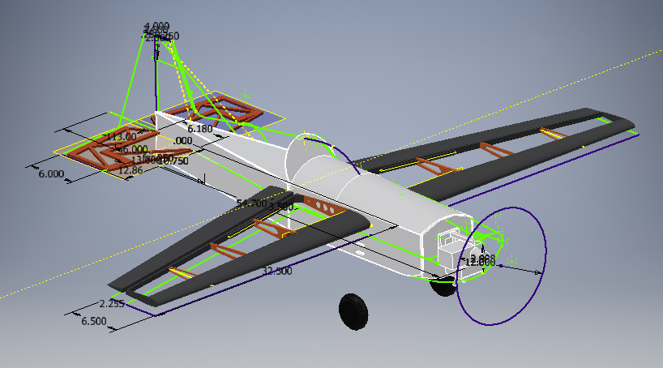
The original CAD model for the Edge 540 60, done in Autodesk Inventor between June and November 2020.

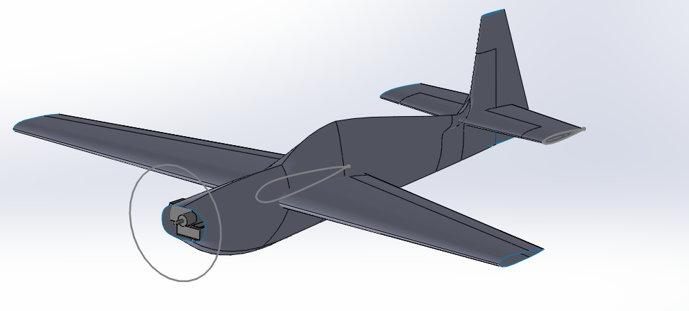
The new CAD model as of today (Nov 26 2020). The Fuselage is just a temporary placeholder. I wanted to experiment with lofting a surface with guide lines. I lofted that fuselage with 2 closed profiles and 4 guide lines!

The hard part going forward will be figuring out how to design a fuselage that adequately does the job, looks cool, hopefully looks kinda like an Edge, and is very manufacturable.

Another thing I’ve learned (or at least had reinforced) at Strato is that there really is no need for a perfect, complex CAD model. At the end of the day CAD is just a tool. In theory, the engineering is really just the output and the analysis that gets you there. If designing on paper is the best way to do it, then great. This is ignoring the educational part of building something, but still. With that in mind, I am embracing the idea that my CAD should be as simple as possible. My wing ribs and fuselage bulkheads may simply be modeled as surface profiles. Whether I try to model this aircraft in FEM is TBD. With solidworks it is very possible to do that.

With the CAD model and Excel sheets now on my new (primary) computer, I think it will be more natural to do work.

A couple other last minute notes:
- I am currently designing around an electric conversion option. I intend to build it with my SuperTiger 65 engine, but I want the option to switch to a 6S Lipo Electrical system
- It’s not finalized, but I would like to build in the space for a pixhawk. This is mostly for data collection purposes. I don’t have specific plans to use one (and I don’t really want to spend the money), but it would be very interesting from an over-engineering perspective to have full data collection capabilities. Probably couldn’t do 3D flight with all that extra weight, but it would be nice to have the rpm data that you can get from an electric motor and my rpm speed sensors (from the Igloo VTOL Project)
- I recently started pulling aerodynamic load data from XFLR5. A big part of the ambiguity is deciding what load factor I should design to. It depends on max speed and how hard I’ll pull on the elevator at high speed. Seeing as this is intended to be a 3d airplane, it has a LOT of control throw. One of the limiting factors is the 25 mm (~1 inch) carbon tube I bought for this airplane. Unfortunately I’m not certain what the strength of that carbon is.

November 27, 2020

Moving forward, areas to focus on:
- Refining the W&B for Nitro and Electric powertrain options
- Look at servo options, do I want to buy servos?
- Figuring out what the fuselage loft is going to be and how I’ll build it
- Tail Structure
- Updating the wing structure in Solidworks, doing more structural analysis on it

Another nice-to-have “Requirement:”
- Swappable servo mounts for variable servo sizes.

December 4, 2020

This week I have made some progress on lofting the fuselage and including detail for the aircraft’s internal systems (like servos, batteries, electronics etc). I expect I will probably get to a workable fuselage loft tomorrow. I want to add a sketch profile near the leading edge of the vertical tail to make it a cleaner shape. Also I need to add two more guide lines so the loft lines that outline the shape of the bottom of the fuselage converge at the bottom of the tail. The sketches shown in the image below represent my current expected location for fuselage bulkheads. It’s very possible that as I get into the detailed design of structure it becomes apparent that I need more.

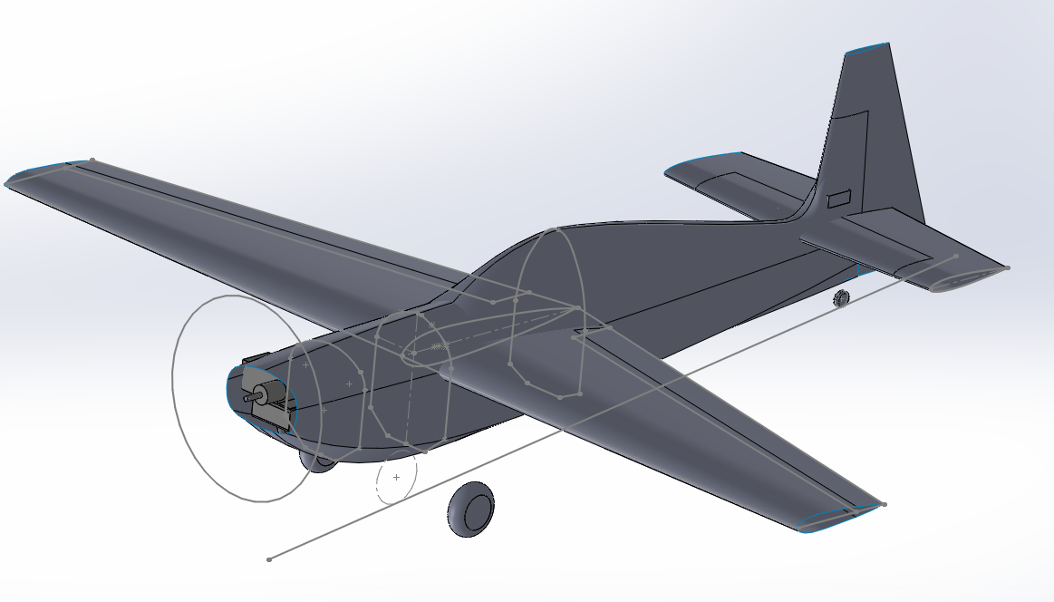

Something that is really frustrating me is the fact that I still don’t have a good understanding of balsa, ply, CA, or wood glue material properties. The wood bending tests I did previously were basically inconclusive because the numbers varied so much. Also, because they were bending flexure tests, I doubt they would be good for tensile test data.

I haven’t spent that much time looking at it in detail, but I think I want to have a plywood box that encapsulates the wing-attach structure, landing gear mounts, and possibly the firewall. Then I can have balsa structures that reach aft to the tail of the aircraft. The turtledeck surface will probably be balsa sheeting, though there’s a possibility that I go for foam instead.

The space just above the main wing (between bulkheads 1 and 2) will be an access panel. I would like to either:
- Have it be a stressed structural access panel
- Have structural members, such as a dorsal keel, run through that space.

December 5, 2020

I did it. I “finished” the loft for the Edge 540!!!

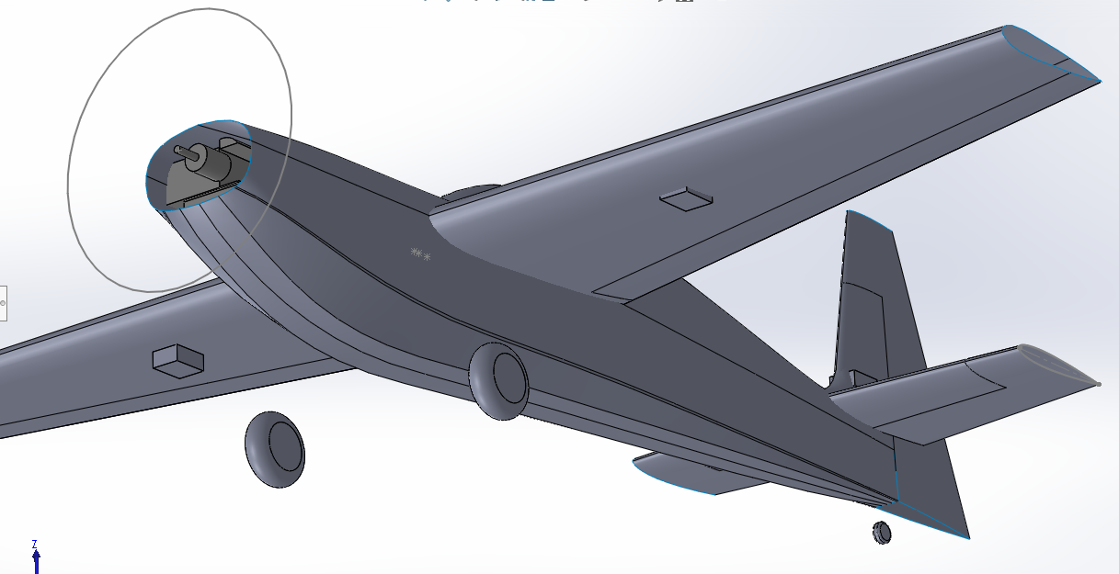

While I’m at it, this is how I’m defining the bulkheads:
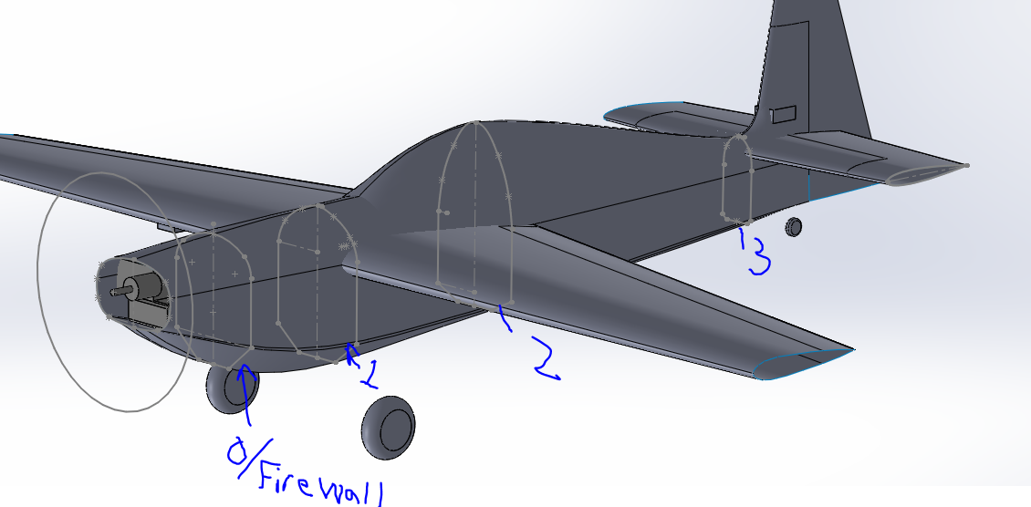

Admittedly, what is shown is not the structural outlines, but rather the sections used to make the loft. Now that I have the loft nailed down, I can go through and start defining the core fuselage structure. I’ll start out by stealing the outlines of the loft, and then I can start figuring out the primary longerons, stringers, and sheets. That will all drive the shape of the bulkheads.

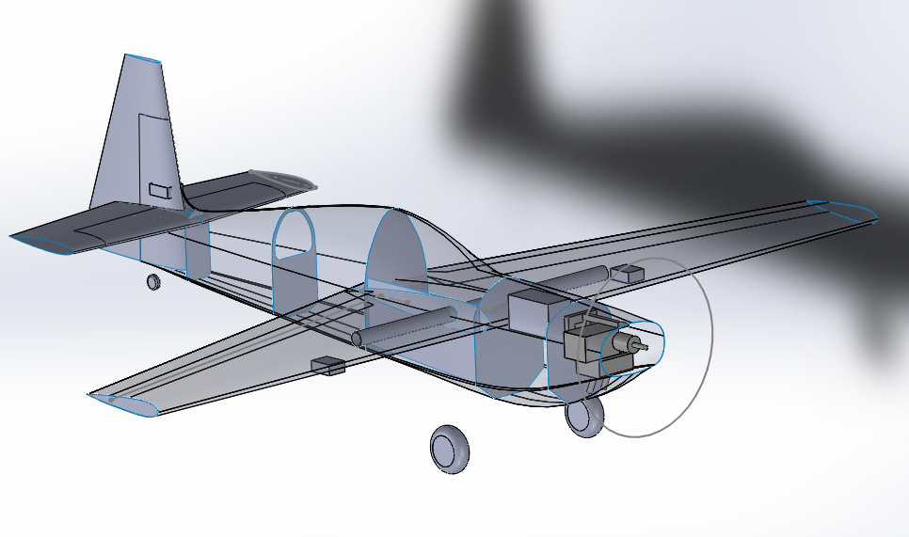

This was my progress at the end of the day. I’m still considering my options for fuselage structural layout. This was my first concept:
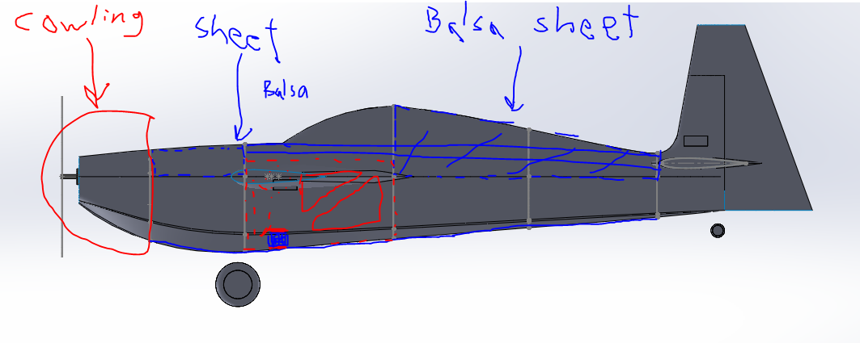

The fuselage works as an I-beam between the basla keel-thing that runs through the access-panel hole and then runs in the center of the turtle deck. This “cap” opposes sheet in the bottom of the fuselage. The primary torsion load path in the tail is through the turtle deck, which is covered in balsa sheeting.

There’s a couple problems with this configuration. Firstly, the top “cap” is not in a good place for good load paths. It is essentially floating in the center of the bulkheads, which means the bulkheads would probably be under considerable bending. Also, as drawn, there’s nothing connecting the top cap with the bottom “cap” (bottom sheet). This means there’s no good shear load path between them, and it all has to pass through the bulkheads. There might be solutions to this, but they aren’t great.

In response to this issue, I made this:
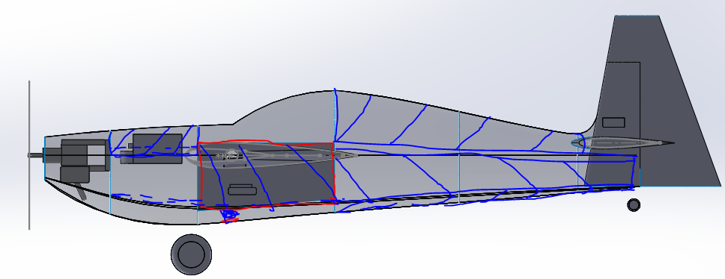

This concept solves the above problems by instead moving the I-beam structure outboard to the skin of the plane. Here I can use vertical balsa sheeting for my shear web. A theoretical disadvantage of this is the fact that the vertical spacing of the “caps” is decreased. I’m not sure if that will matter much in practice. A possible variation on this scheme would be to, instead of using balsa stringers for my caps, I could use sheet that spans the width of the aircraft.

Here’s another variation:

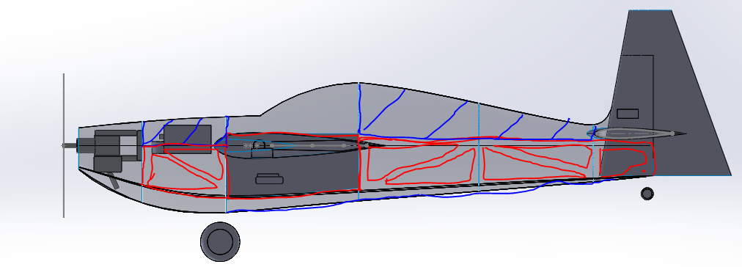

As you can see above, this configuration incorporates a lot more plywood. One thing that’s interesting is that it may be possible to have the ply members on the sides and then balsa sheeting on the bottom, but nothing (besides the bulkheads) in the diagonal space between. If I did that, the balsa wouldn’t serve much structural purpose, but rather act as a cosmetic feature. It is presently unclear to me whether I would want/need some sort of structure acting at the top/bottom of these ply side members. In theory, I could laminate on some balsa to act as a cap, or I could span a piece of similarly lightened ply across the top (and possibly bottom) to add x-axis stability with respect to each other. This also has the effect of acting as a shear web for Mz bending moment. This isn’t the primary load direction, but it will do something because we have a very powerful rudder and I expect to do lots of spins and (hopefully) knife edge flight.

I have decided, for the sake of simplicity, that all bulkhead surfaces will be extruded aft. Also, I will add a balsa feature (or two) at the top of the turtledeck so I don’t have to wrap balsa around that tight corner.

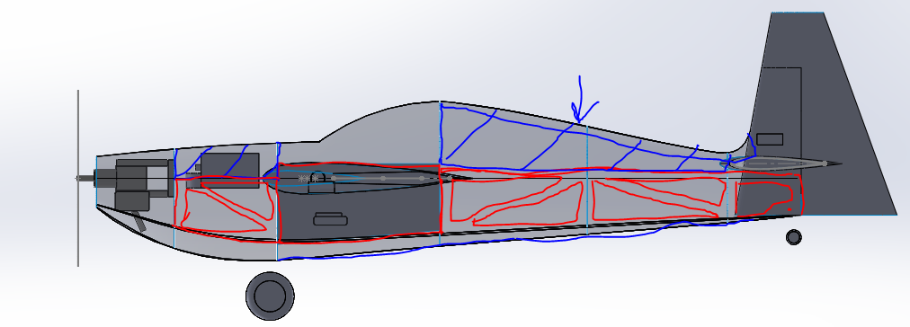

The wing box will extend forward to the firewall at its own spacing. This spacing is less than the nominal width of the fuselage there, so it will also have small pieces of balsa on the sides for cosmetic purposes.

For control surface gaps, I’m shooting for .125”, and they will be centered at their locating dimensions.
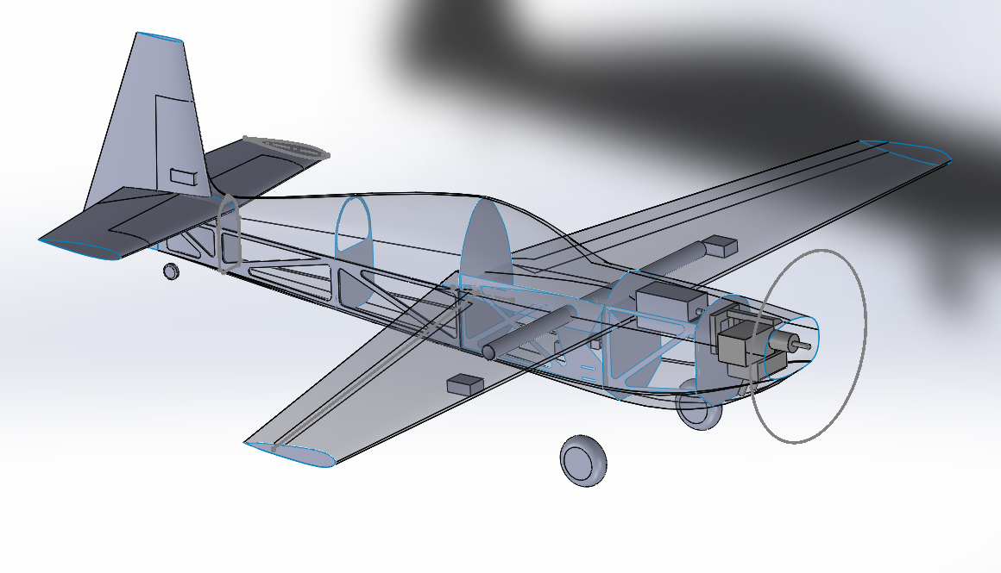

I was able to incorporate this structural design into my Cad model with surfaces. With the aft side brace, you can see that I went ahead and extruded it out into a 3d part. I have started tallying a weight and balance estimate of the fuselage in my excel sheet. I’m also incorporating the mass of my old the wing from my old Inventor CAD model for a preliminary estimate of the aircraft’s mass. This will definitely continue to evolve as I progress, but I’m hoping to use it in a somewhat closed-loop fashion for designing this aircraft. Next up I need to incorporate a workable structural design for the tail surfaces. I already hashed this out on paper when I was adjusting the tail and main wing dimensions, but I need to put it in CAD. This should help me get a weight and balance estimate of the tails, which helps me estimate the CG location of the aircraft as well as (hopefully) a better guess of the fuselage bending moments the aircraft could see. In an ideal world with realistic structural allowables on hand, I could use this to refine the fuselage design. This would in-turn help nail down wing loads. Improved aircraft W&B understanding would follow, which could be used to inform my stability analysis, performance, structural loads, etc. I’m very excited to see how things will evolve!

December 11, 2020

It looks like I will be out of California for the Christmas season, so I’m trying to think ahead to how that will affect my ability to progress on this project. I expect to leave on the 19th, which is quickly approaching. The advantage of this time is that, if armed with the right information, I could use it to do more in-depth analysis and design. That said, I want to avoid the trap of doing analysis for the sake of analysis.

This is a complicated subject, because on one hand this is just an RC airplane. It’s relatively simple, and the cost of failure is low. I could easily just “that-looks-about-right” everything, and it will probably be okay. On the other hand, I can potentially learn a lot from doing extra analysis. I’m sad to say that the former is most of what I have done so far, but at the same time, I’m trying to be fairly aggressive with respect to performance (esp weight). I’m designing this as lightweight as I can, and I want to have minimalistic batteries, servos, and other components. Without any analysis or engineering understanding, that increases the odds of failure tremendously. It would be nice if I could do just enough engineering that I reduce the odds of total failure and learn a bunch without it becoming “rocket science.” Rocket Science will come later…….

I had planned to design around a set of very nice servos, receiver battery, etc, but alternatively I could do my initial test flights with cheaper components that I already have. For the receiver battery, that’s not a big deal. With servos it is a little harder because you have to house them somewhere. I was interested in using Blue Bird servos, but it looks like they don’t have any great options for my estimated torque range.

Figuring out what torque level I need has been a big challenge. I haven’t yet come up with a good way to estimate it, but I might figure that out later. As a starting point, I looked at Extreme Flight RC’s 64” wingspan MXS to see what servos they recommended. They had three different offerings that each delivered 150-200 oz-in of torque (depending on voltage and servo) and weighed less than 40 grams. Downside is all three options are in the $70-95 range. This may not be cheap. This is further incentive to initially fly with cheap servos, but then move to the fancy servos to maximize performance. This requires swappable servos.

Another question… is it worth doing much engine testing? What if I build this airplane around my supertiger engine then find out it doesn’t have enough static thrust to hover this plane? I intend to have nitro/electric power flexibility, but multi-engine flexibility is a different question. I guess this is just more motivation to build the most lightweight aircraft possible.

